Lab 5 CCS3104
19 December 2025
- Solve the following questions and demonstrate your solutions to me in this lab, the next lab or at the start of the lab after next. This is a 2-weeks lab. For record-keeping, submit also your solutions and screenshots of their output to PutraBlast.
- Evaluation will be done according to the lab rubric on PutraBlast. I will ask questions accordingly.
*******************************

Questions:

- Given the following slide in the Networking lecture slides:

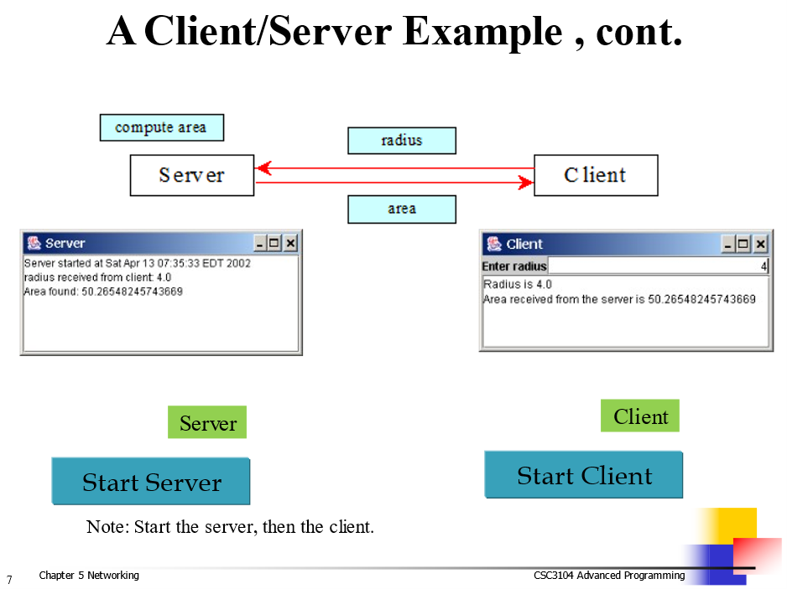

redo the example using RMI.

